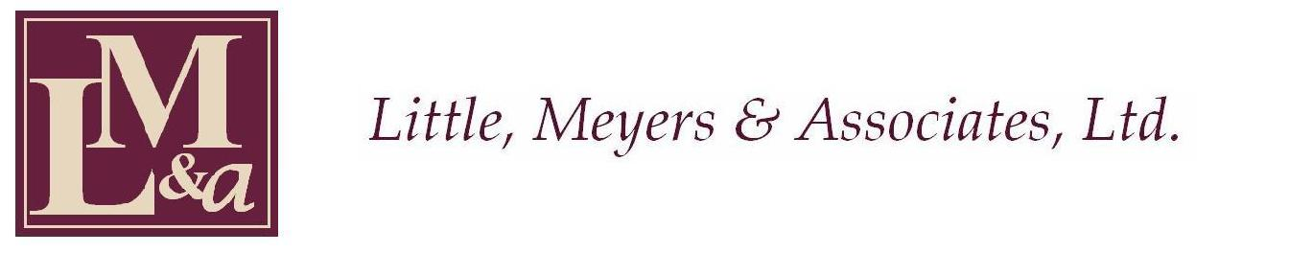

PRESS RELEASE May 19, 2010

Local Attorney Receives National Award

The National Structured Settlements Trade Association, headquartered in Washington, D.C. and dedicated to education and legislation for catastrophically injured claimants and their families, presented Karen D. Meyers, MBA/JD, MEd, CPCU, CLU, FLMI, CSSC the prestigious President’s Award for her extensive contribution to the structured settlement industry. Meyers is a partner in the firm of Little, Meyers & Associates, LLC and did wide ranging work with the families of victims of the September 11th tragedy in New York, Washington D.C., and Pennsylvania and has served as a Settlement Master in various class action settlements. She is a summa cum laude graduate of Thomas More College with two Master’s Degrees from Xavier University and a Juris Doctor from Salmon P. Chase College of Law at Northern Kentucky University as well as a CLU, FLMI, CPCU, and CSSC. She is a part-time faculty member at Miami University Farmer School of Business, co-developer and faculty member of the Certified Structured Settlement Consultant Program offered at the University of Notre Dame in South Bend, Indiana and serves as Chair-Elect of the Christ Hospital Family Centered Care Council and the Ethics Committee of The Christ Hospital and Regency Hospital of Cincinnati.

2651 Observatory Avenue ▪ Cincinnati, Ohio 45208 ▪ Phone (513) 871-8900 ▪ Fax (513) 871-9099

